Use this reference to create an EIB (Enterprise Integration Builder).
EIB is a guided and graphical no-code integration tool designed to help institutions extract and transfer mass amounts of Workday data with ease.

Contents
(Ctrl+click to jump to content)
Create EIB 1
Generate EIB Spreadsheet Template 5
Launch EIB Template 9
Update EIB Template After Workday Release 12
Check Existing Template for Update Requirements 12
Update Existing Template Model 14

Create EIB

- Login into Workday. In the search bar, type “Create EIB”.

- In the Name field, type a descriptive name for the new EIB, select its direction and click “OK”. In this example, the intent is to import data so “inbound” is selected.

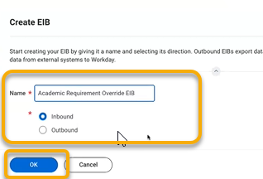

TIP: Before you name the new EIB, check to confirm the name is not already in use. In the Workday search bar, type “Launch / Schedule Integration”. In the Integration field, type keywords describing your new EIB. Existing EIBs with similar keywords will auto-populate. Do not use the name of an existing EIB.

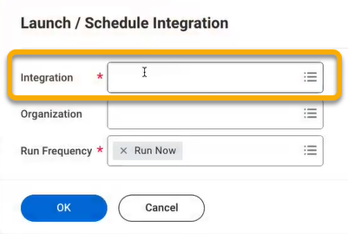

- On the General Settings page, click “Next”.

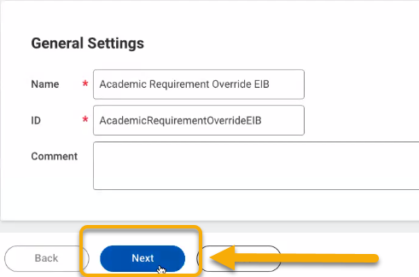

- On the Get Data page, scroll down to the Data Format heading.

- Find the “Web Service Operation” field and type keywords for the operation you are seeking. The field will auto-populate with proposed matches.
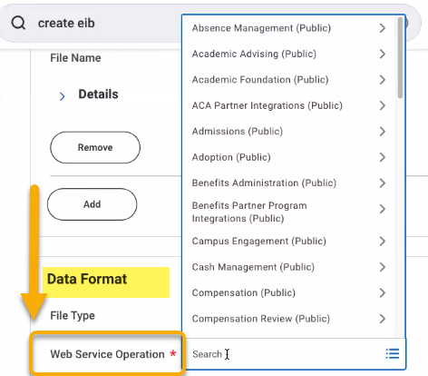
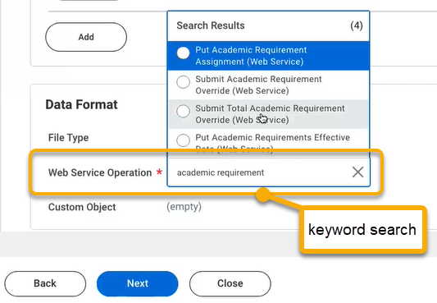
- After review, select a web service operation and click “Next”.

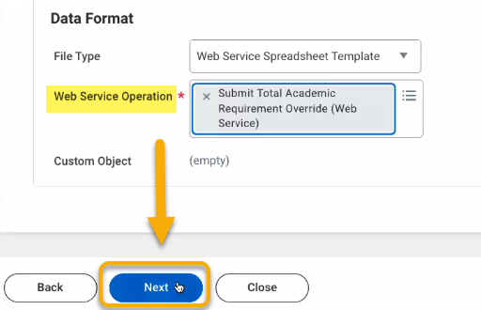

- On the Transform page, click “Next”.

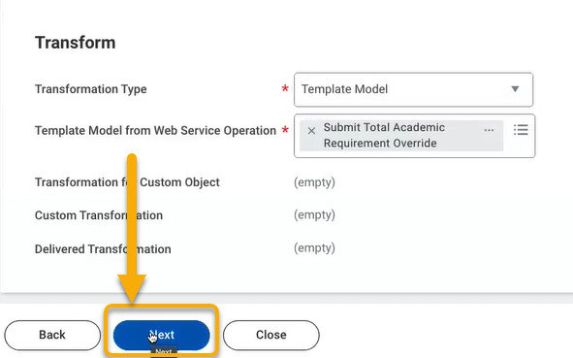
- On the Deliver page, click “Next”.

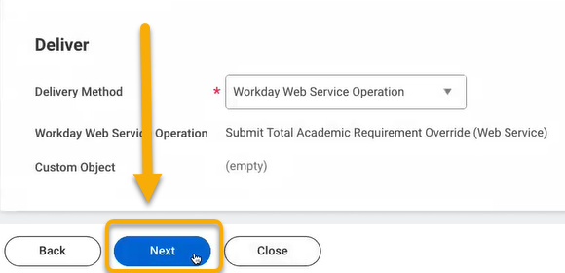

- On the next page, under the Get Data heading, click “OK”.
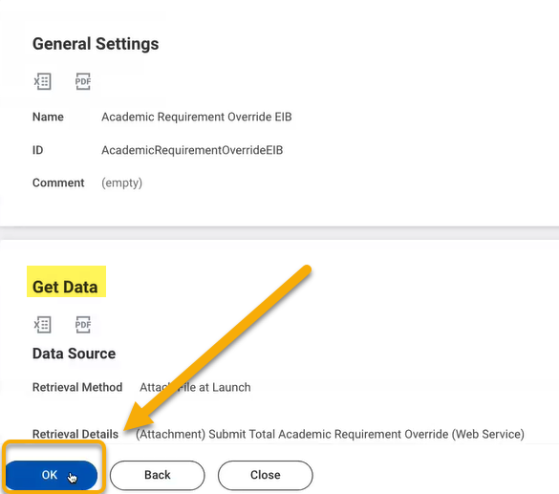

Generate EIB Spreadsheet Template

Once the EIB is created, you will need to generate a spreadsheet template to populate the data. To do so, follow these instructions.

- On the View Integration System page, follow these steps to download a data spreadsheet template:
- Click related actions button to reveal more options,
- Hover over “Template Model”,
- Click “Generate Spreadsheet Template”.

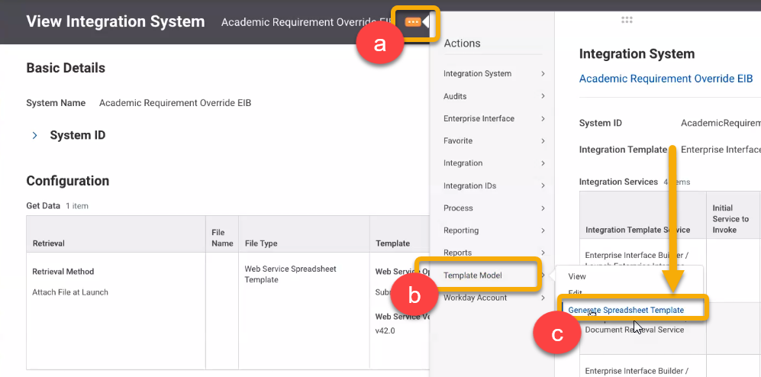

2. The Generate with Data page will open. Click “Submit”.

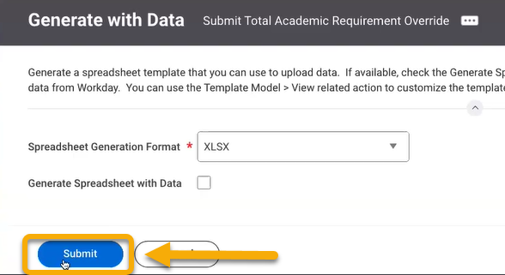

3. On the View Background Process page, click “Refresh”.

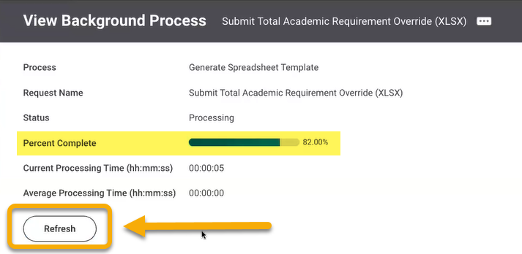
The Percentage Complete bar will show processing. Continue clicking “Refresh” until the button disappears. You will also receive notification of the finished report in the top-right corner of your screen.

4. Click the finished report notification, download, and open.

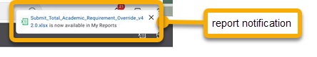

TIP: To find your Integration System page for your EIB in the future you can search with the prefix ‘Intsys:’ and the name of your EIB.

5. The report will download as an excel file. Open and review. Sort the Spreadsheet Key column to organize data in numerical order.

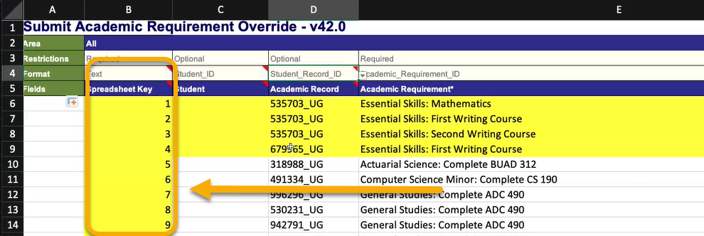

6. Fill the data in to the correct columns.

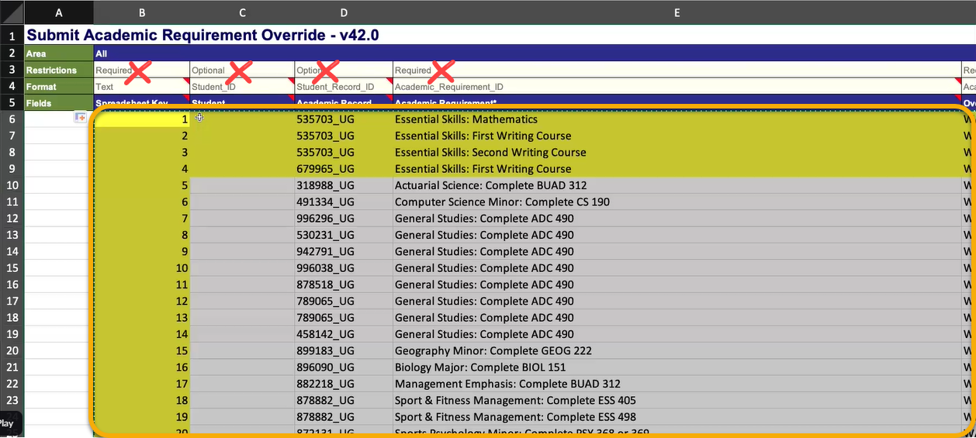

Launch EIB Template

- When report is compiled and complete, upload and integrate into Workday. To do this, search “Launch / Schedule Integration”.

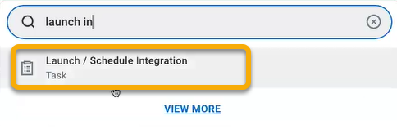

- On the Launch / Schedule Integration page, type the name of the EIB from step 2 into the Integration field. Click “OK”.

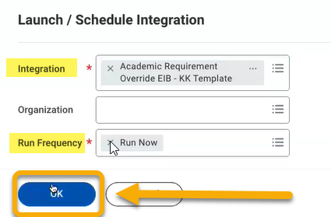

- The Schedule an Integration page will open.

Find the Integration Attachment field and coordinating Value field.

Click the Value field.

Click “Create Integration Attachment”

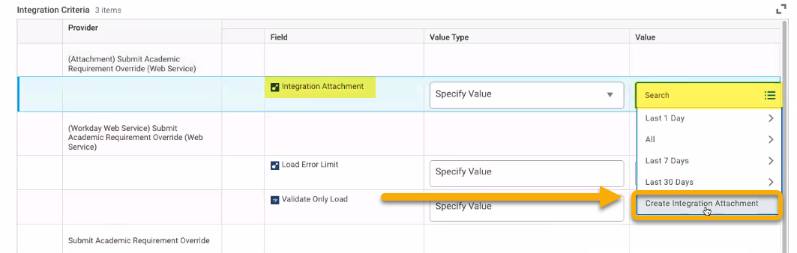

This will prompt you to select and upload the EIB file from your computer. Complete this process and upload.

When successfully uploaded, you will see a confirmation message. Click “OK”.

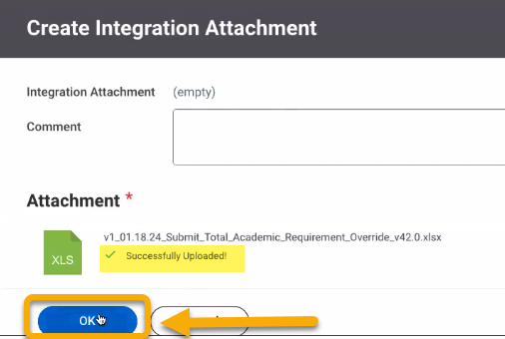

- When the upload process is complete, scroll down and click the Validate Only Load button.

Click “OK”.

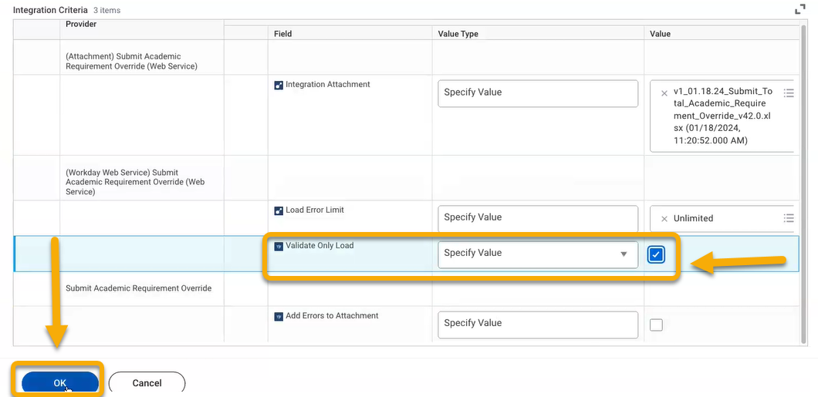

- The View Background Process screen will open. Like before, click “Refresh” until complete.

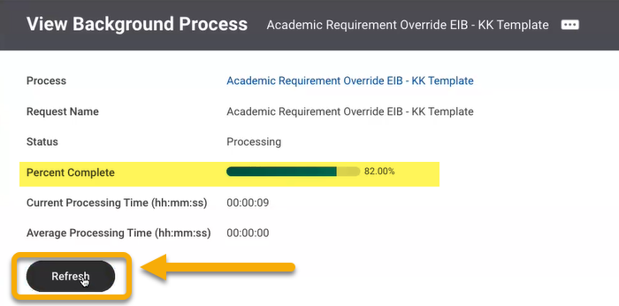

- Once the processing is complete, you may receive the Status: Completed with Errors.
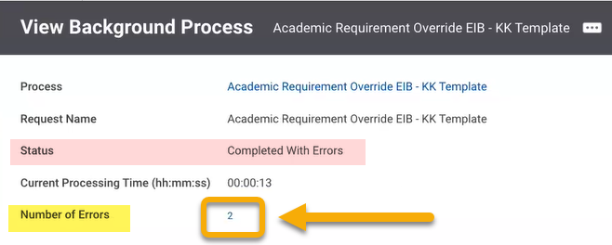

To view the errors, hover over the number in the Number of Errors field.

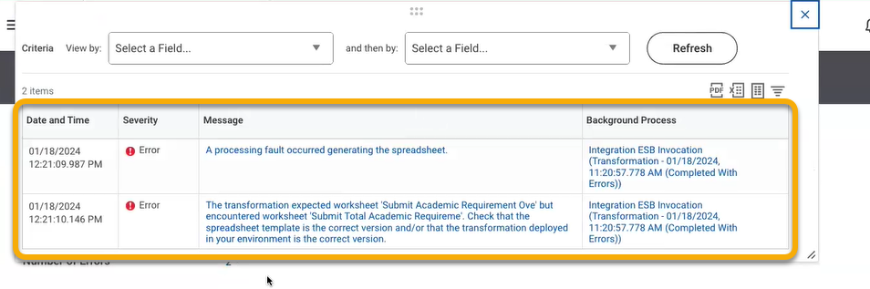

To view error details, click the hyperlinked error message. Use the error details to identify the error and find a solution.

Update EIB Template After Workday Release
Workday feature releases have the potential to impact existing EIB templates. As a result, we recommend you create new templates after each release date to avoid disruption. In fact, when reviewing an existing EIB, you may receive an alert reminding you to update your template.

Check Existing Template for Update Requirements
To review an existing template for the purposes of updating the template, follow these instructions.
      - In the search bar, enter “intsys: [name of EIB]”. In my example, I will use an EIB called Test Scores.
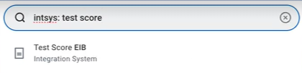

      - On the View Integration System page, locate the Template column in the Get Data table. It will list the current version of the EIB.
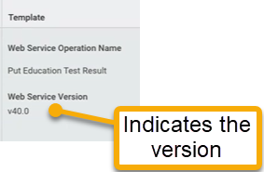
Next, click the View Integration System page’s related actions. Select “Template Model” and select “View”.
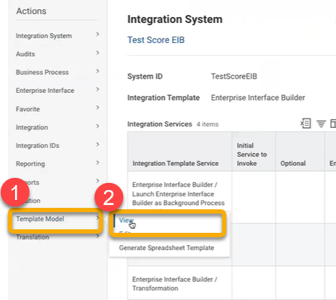

      - From the View Template Model page, you will see the version field again.

Proceed to the bottom of the page and look for the following alert:
It reads: Template Generation with Data is not supported for web service versions more than 18 months old. Update your template model using the Template Model > Generate Default Template Model related action.
This means you must update this template model.

Update Existing Template Model
You will now update the existing EIB template model to ensure every use of this template results in the correct data fields. While these fields could be corrected with each use, it is best to make these changes to the template model.
            - From the View Template Model page, open related actions. Select “Template Model” and select “Generate Default Template Model”.
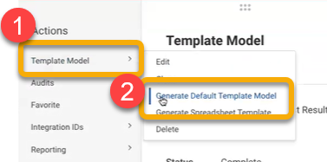

            - From the Generate Template Model page, locate the Version field. You will notice a new version compared to the original template.
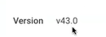

      - Leave all fields as is. Click “OK”.

      - Return to the View Template Model page of your EIB. If the tab is not still open, return to the search bar and enter “Intsys: [EIB Name]. Then, click related actions. Select “Template Model” and select “View”.
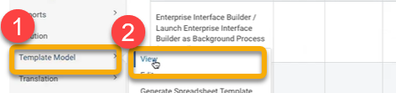

      - On the View Template Model page, you will also see a left-hand menu. Select various items in the left-hand menu to review details.

In this example, I select “Has Academic Unit Data+”.

      - Locate the Label column and note the item listed.

      - Scroll to the right and locate the Reference ID Type column and note the item listed. Confirm they are an appropriate match. After a new Workday feature release and subsequent EIB template update, these reference ID types may sometimes default to a new value. You will need to manually assess and correct these values.

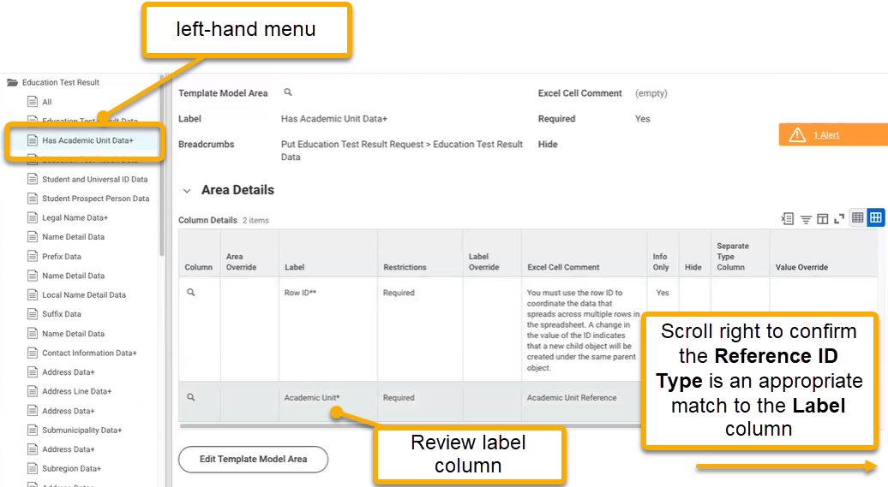

In my example, I see Academic Unit in the Label column.

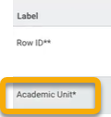

In the Reference ID Type column, the value changed from Academic Unit ID to Academic Unit Hierarchy ID.

Now, I must manually correct this. I want to make sure Academic Unit Hierarchy ID is replaced with Academic Unit ID instead.

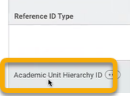

- To edit or correct a value in the Reference ID Type column, locate and click the “Edit Template Model Area” button.
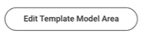
- In the Column Details table, scroll to the right and locate the Reference ID Type column. Select the field and locate the correct value.
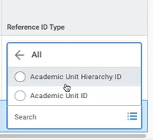
- Click “OK”.

- Click “Done”.

Continue this process across each item in the left-hand menu.

